**University of Michigan – Dearborn**

**CIS 150 – Computer Science 1**

**Lab# 7**

Quan Le

[lmmquan@umich.edu](mailto:lmmquan@umich.edu)

March 5, 2024

**Table Content**

Contents

Question 1 3

Test Cases 3

Source Code 4

Screenshots 4

Question 2 6

Test Cases 6

Source Code 7

Screenshot 7

# Question 1

## Test Cases

|  |  |  |  |  |  |
| --- | --- | --- | --- | --- | --- |
| Test # | Valid / Invalid Data | Description of test | Input Value | Actual Output | Test Pass / Fail |
| 1 | Valid | Testing to see if the program correctly prints the name and salary of each employee in the new file | John Tourn 10 15  Sasha Johnson 40 12  Stephan Taylor 27 13  Jim Mcpherson 25 8 | John Tourn 150  Sasha Johnson 480  Stephan Taylor 351  Jim Mcpherson 200 | Pass |
| 2 | Valid | Testing to see if the program correctly prints the name and salary of each employee in the new file | John Tourn 23 2  Sasha Johnson 44 9  Stephan Taylor 30 12  Jim Mcpherson 25 15 | John Tourn 46  Sasha Johnson 396  Stephan Taylor 360  Jim Mcpherson 375 | Pass |
| 3 | Valid | Testing to see if the program correctly prints the name and salary of each employee in the new file | Richard Huang 4 23  Timothy Tanaka 0 11  Edward Seo 21 0  Freddy Murphy 2 15 | Richard Huang 92  Timothy Tanaka 0  Edward Seo 0  Freddy Murphy 30 | Pass |
| 4 | Valid | Testing to see if the program correctly prints the name and salary of each employee in the new file | Richard Huang 40 50  Timothy Tanaka 25 16  Edward Seo 18 12  Freddy Murphy 40 80 | Richard Huang 2000  Timothy Tanaka 400  Edward Seo 216  Freddy Murphy 3200 | Pass |

## Source Code

The source code for this question has been uploaded to Canvas as lab7q1.cpp.

## Screenshots

Test Case #1

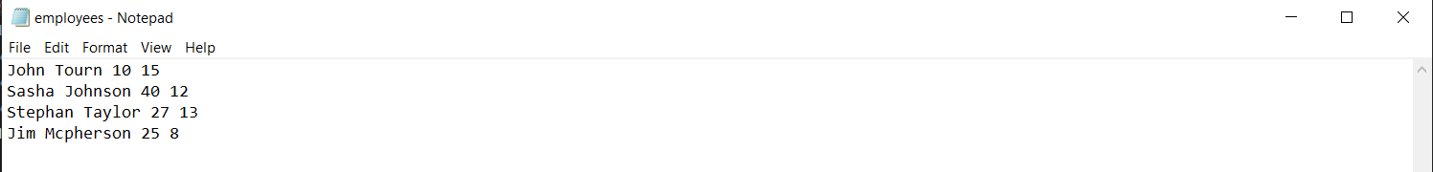

Test Case #2

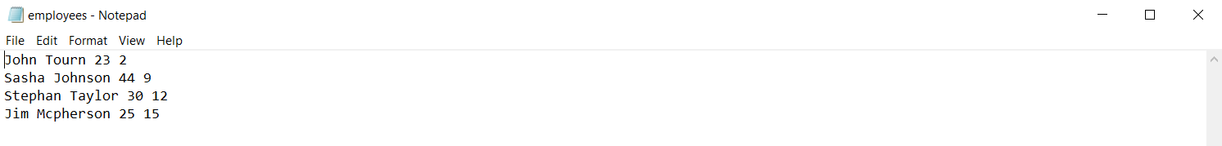

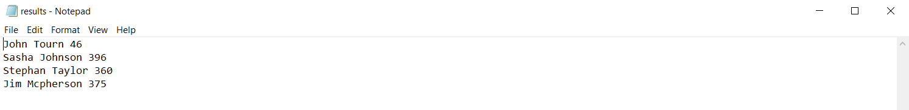

Test Case #3

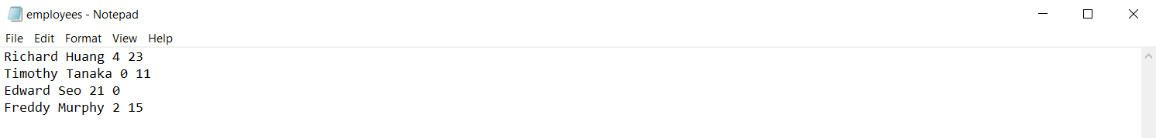

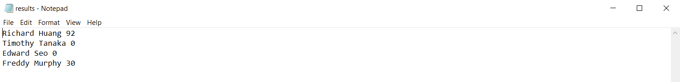

Test Case #4

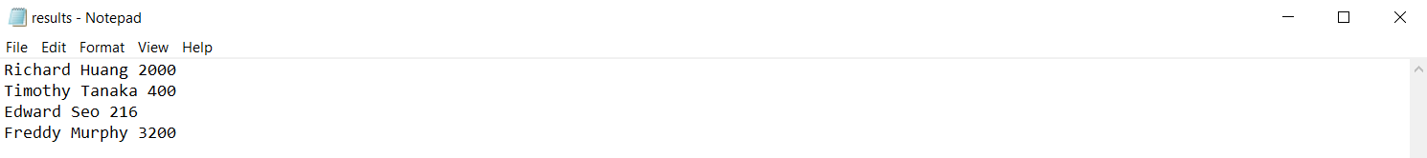

# Question 2

## Test Cases

|  |  |  |  |  |  |
| --- | --- | --- | --- | --- | --- |
| Test # | Valid / Invalid Data | Description of test | Input Value | Actual Output | Test Pass / Fail |
| 1 | Valid | Testing to see if the program can correctly calculate the average score and the highest score | Matthew Williams 80  Joe Castleton 67  George Cook 62  Tom Dawson 98  Alfred Mallard 40 | The average is: 69.4  The highest is: 98 | Pass |
| 2 | Valid | Testing to see if the program can correctly calculate the average score and the highest score | Matthew Williams 0  Joe Castleton 50  George Cook 50  Tom Dawson 50  Alfred Mallard 100 | The average is: 50  The highest is: 100 | Pass |
| 3 | Valid | Testing to see if the program can correctly calculate the average score and the highest score | James Ramsey 64  Sabrina Joy 89  Diana Simple 50  Arun Annamalai 42  Benjamin Lore 76 | The average is: 64.2  The highest is: 89 | Pass |
| 4 | Valid | Testing to see if the program can correctly calculate the average score and the highest score | James Ramsey 81  Sabrina Joy 35  Diana Simple 5  Arun Annamalai 97  Benjamin Lore 43 | The average is: 52.2  The highest is: 97 | Pass |

## Source Code

The source code for this question has been uploaded to Canvas as lab7q2.cpp.

## Screenshot

Test Case #1

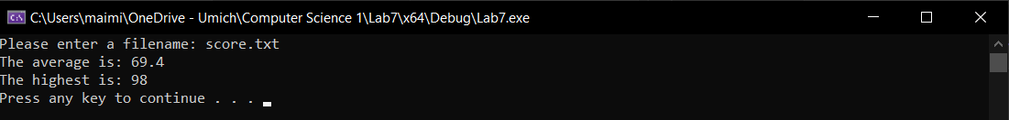

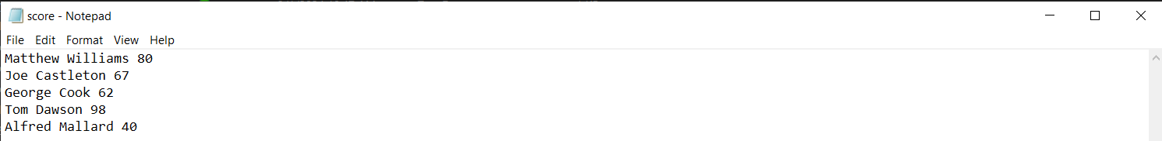

Test Case #2

Test Case #3

Test Case #4

